Report for Lab Assignment 3

**Question 1:** R Project

Prepare a dataset related to your own project and perform k-Means, k-Medians, Expectation Maximisation (EM), Hierarchical Clustering and report the results.

**Description:**

In this lab assignment, I am going to use the clustering techniques mentioned above to try and classify Accelerometer movements. What I really want to do here is see if clustering techniques will automatically classify activities without having to give input knowledge. If we can distinguish specific activities, then it will be must easier for the machine to learn of changes in routine without having prior knowledge of a trend.

For this example, I wanted to keep it simple, so I used three activities that I would not think have similar range of movements. I chose eating, climbing the stairs, and brushing teeth.

**Screenshots:**

**Kmeans:**

The three clusters:

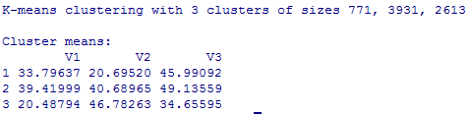

Measuring Sum of Squares:



The Training plot:

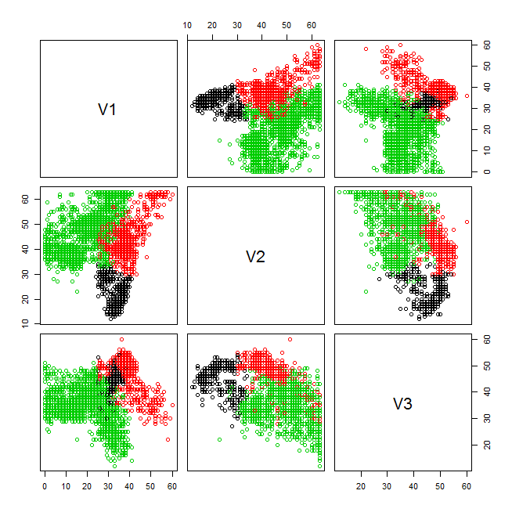

Testing teeth brushing data:

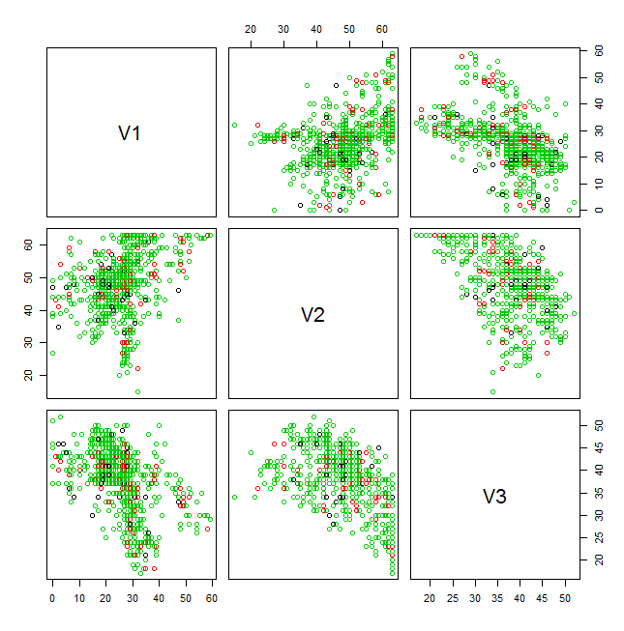

Testing eating:

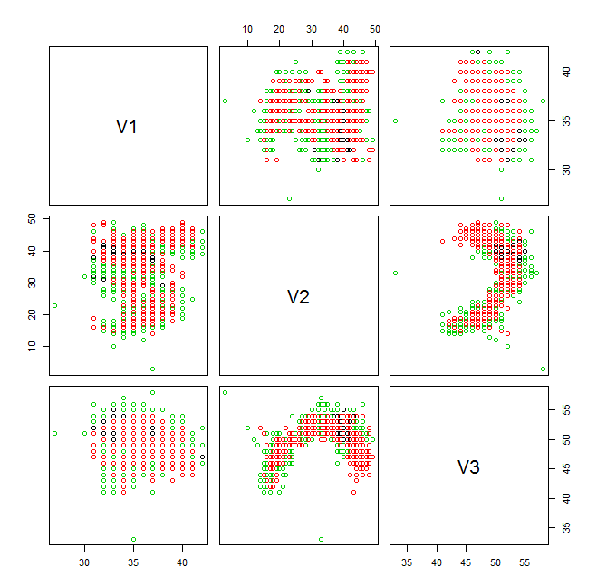

Testing Stairs:

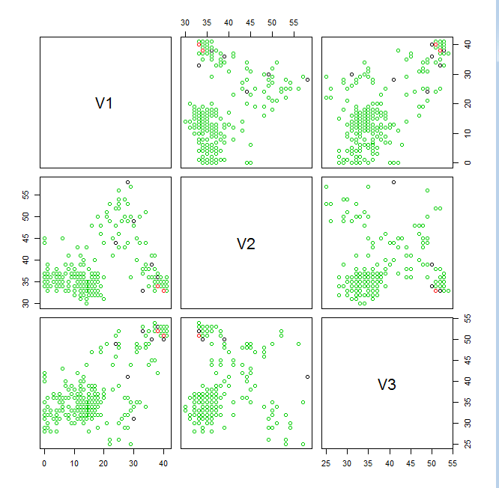

Conclusion for Kmeans:

From a qualitative perspective, the activities seem to follow homogenous clusters. It may not be great at distinguishing between similar activities, but would be useful for narrowing down possibilities.

**Expectation Maximization:** (note that this algorithm took a long time to complete, and did not correctly estimate the right clusters. I would not choose this method for this type of problem, since we know exactly how many clusters we need, and have several data points.

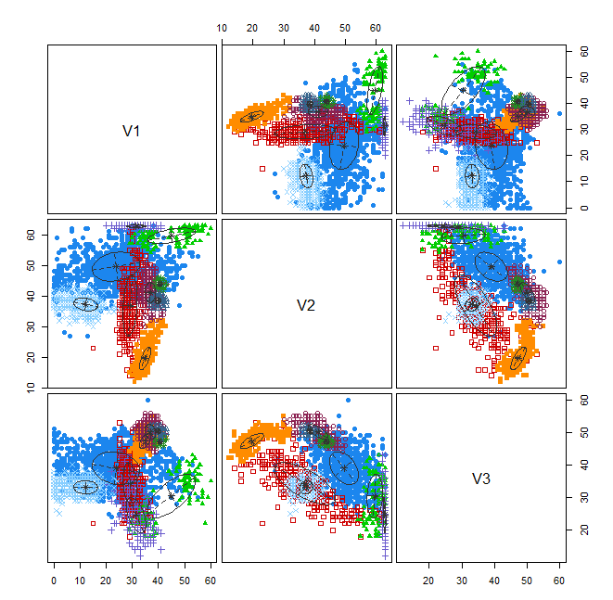

Hierarchial clustering:

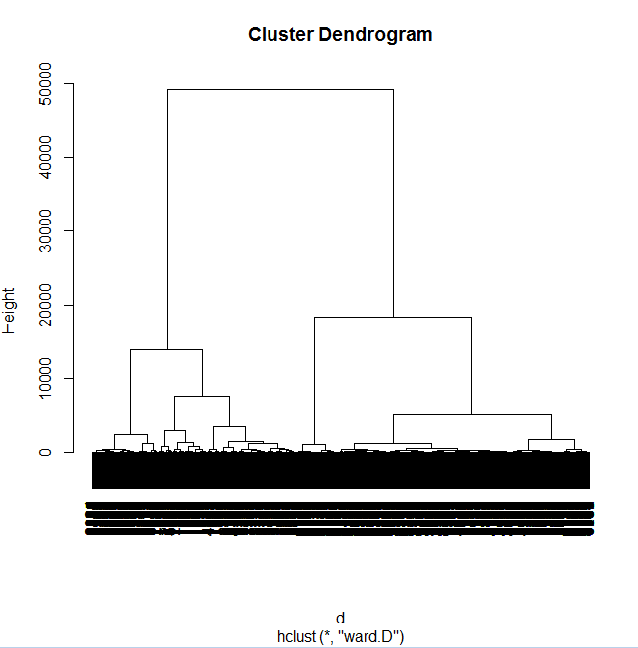

**The code:**

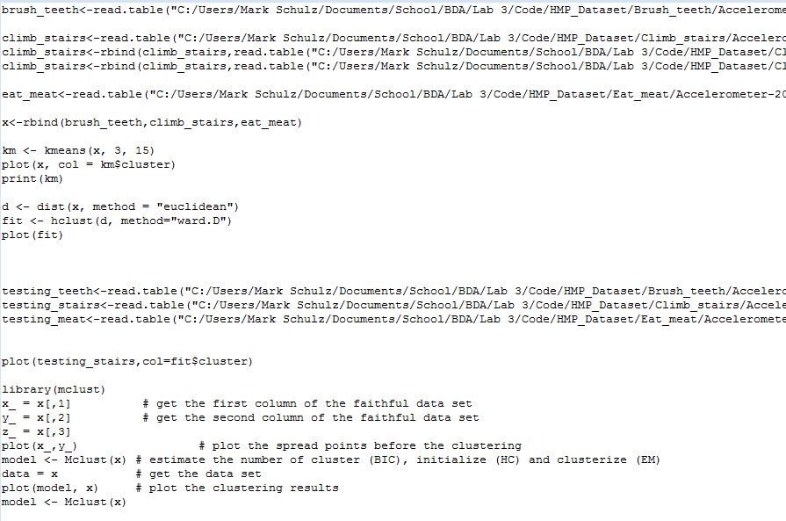

**Question 2:** Watch Application

Data collection related to your own project through Smart Phone and Watch, send notifications to watch using intuitive data analysis.

**Description:**

**Screenshots:**